Jalu Chaudhary

Class IT-314-DL2

City Jail

1.List the following information for all crimes that have a period greater than 14 days between

the date charged and the hearing date: crime ID, classification, date charged, hearing date,

and number of days between the date charged and the hearing date.

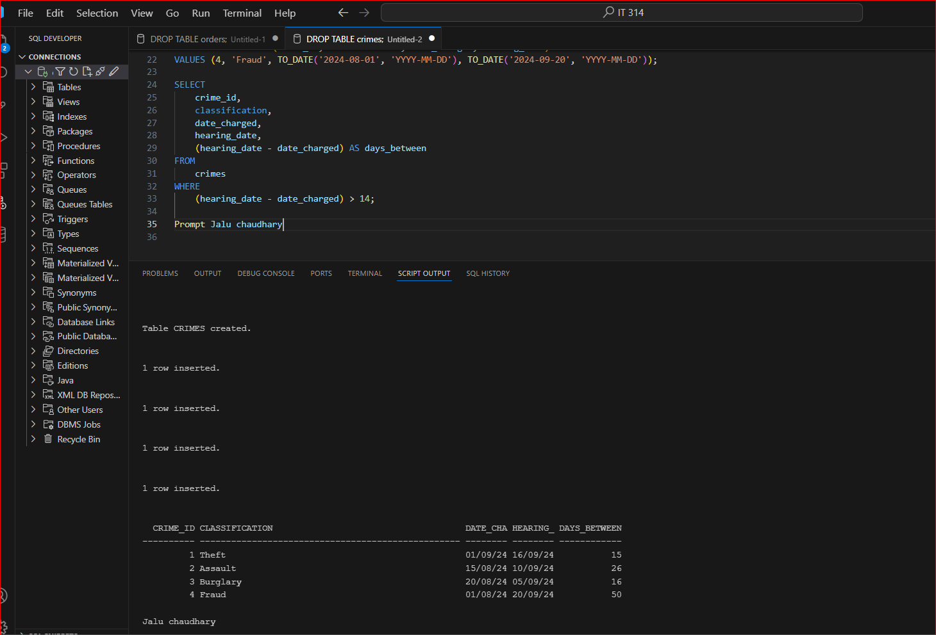

2.Produce a list showing each active police officer and his or her community assignment,

indicated by the second letter of the precinct code. Display the community description listed

in the following chart, based on the second letter of the precinct code.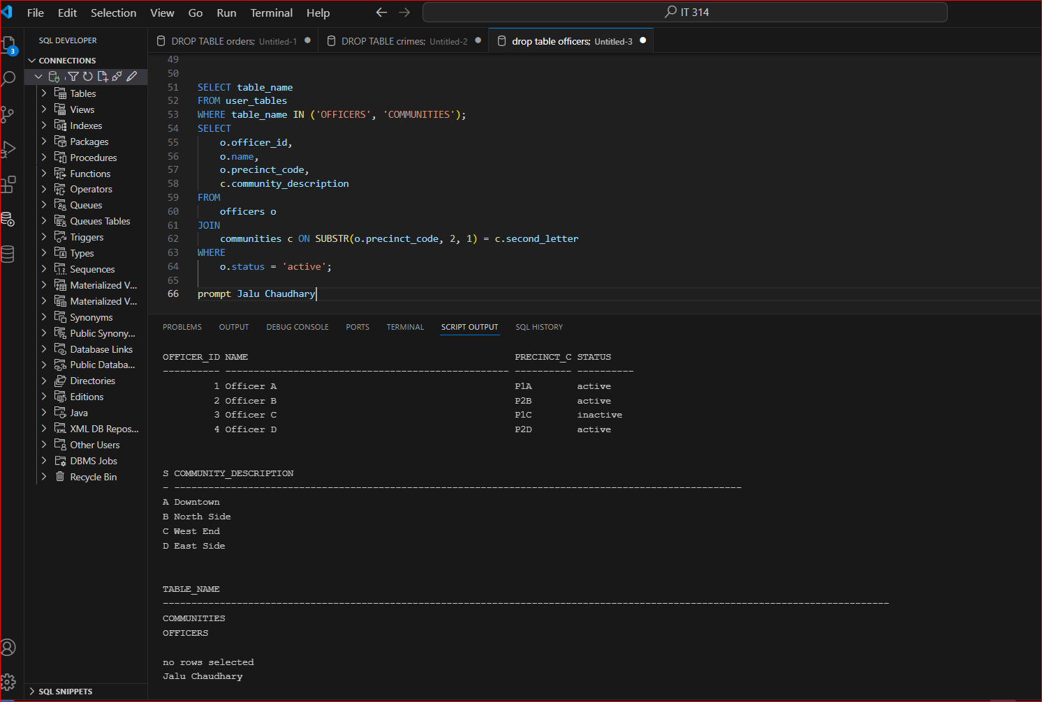

3.Produce a list of sentencing information to include criminal ID, name (displayed in all

uppercase letters), sentence ID, sentence start date, and length in months of the sentence.

The number of months should be shown as a whole number. The start date should be

displayed in the format “December 17, 2009.”

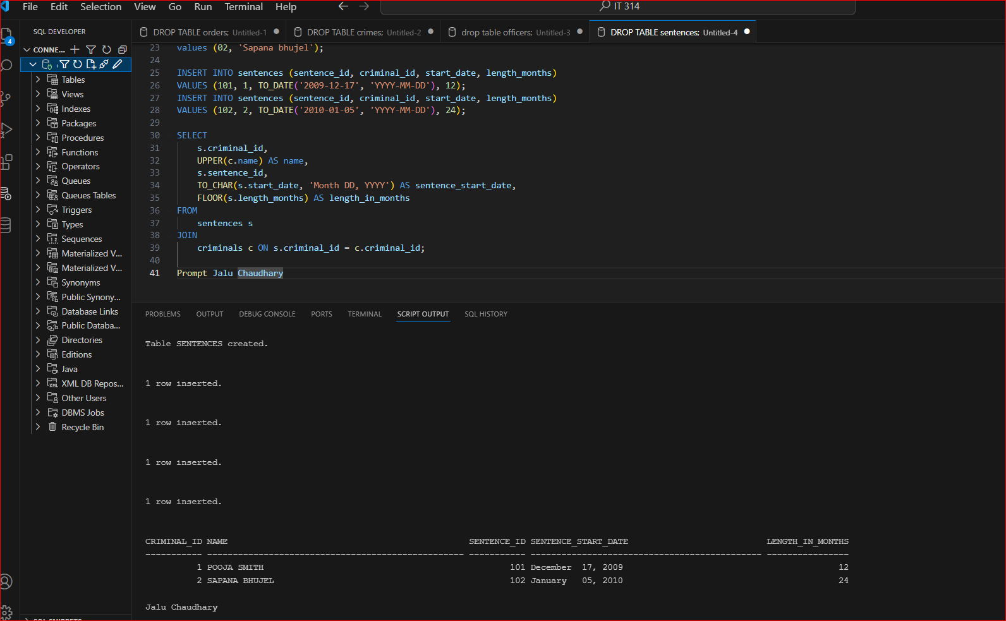

4. A list of all amounts owed is needed. Create a list showing each criminal name, charge ID,

total amount owed (fine amount plus court fee), amount paid, amount owed, and payment

due date. If nothing has been paid to date, the amount paid is NULL. Include only criminals

who owe some amount of money. Display the dollar amounts with a dollar sign and two

decimals.

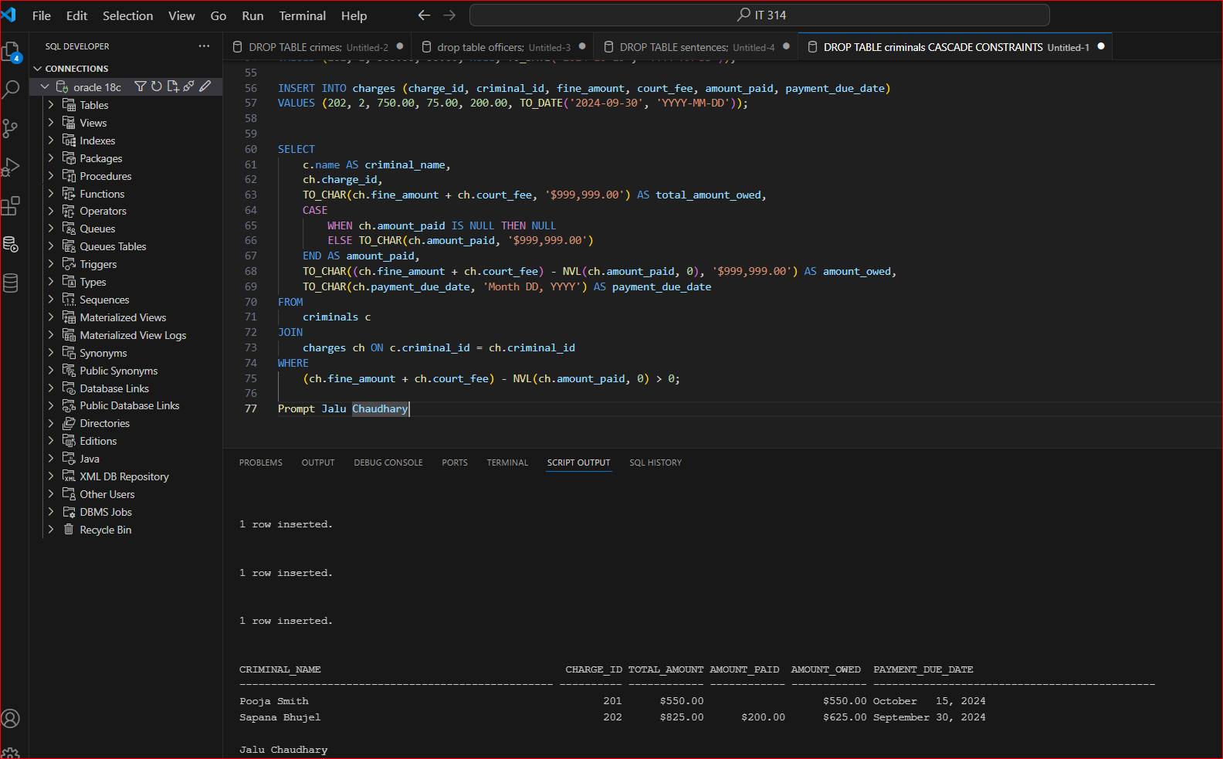

5. Display the criminal name and probation start date for all criminals who have a probation

period greater than two months. Also, display the date that’s two months from the beginning

of the probation period, which will serve as a review date.

